**EECE 350 PROJECT:**

**YALLACHAT**

*25%* Bassam Tarshishi **202302507**

*25%* Mahmoud Chaer **202302465**

*25%* Amir Basha **202205806**

*25%* Omar Chehab **202301375**

**Appendix 1 (with screenshots)**

**Home page:**

**Sign up page:**

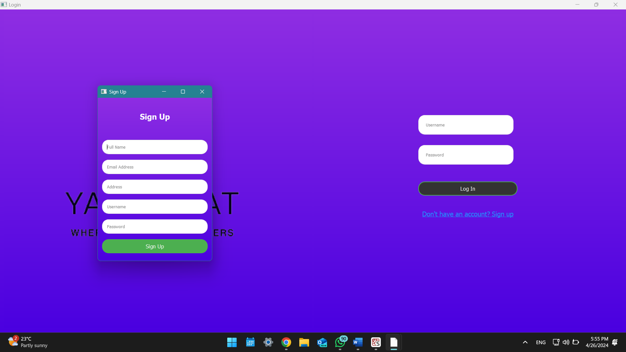

**Main menu: (with window that pops up if the user has notifications):**

**Friend status:**

**

**Send friend requests:**

**Main chat page (with all the needed features):**

**Group chat: (works perfectly but without GUI):**

